Comanche County
Amateur Radio Emergency Services
Standard Operating Procedures

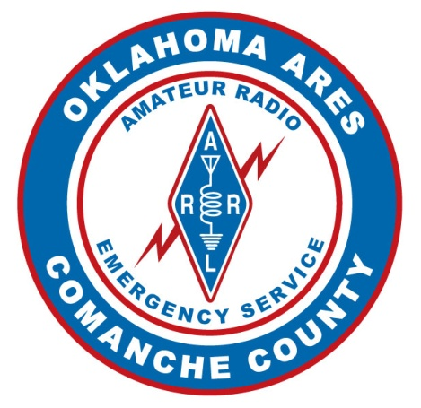

Amateur Radio Emergency Service® (ARES)

Comanche County, Oklahoma

The Comanche County Amateur Radio Emergency Service (CCARES) operating protocols are intended to guide the operation and response of the organization in the case of activation and during periods of training and organization. The design is to allow a single resource for all CCARES members and other area hams to guide the aspects of our collective response to the eventuality of emergency communications being facilitated by amateur radio operators.

It is implemented before activation and maintained by the membership to ensure the readiness of the membership (both knowledge and equipment) and a robust command and control structure for the organization.

NOTE: Events beyond our control may cause changes to our operating procedures. Please contact your team leader if you have any questions.

Table of Contents
1.0 Operational Organization and Structure 3
2.0 Organization Chart 4
3.0 Operational Roles and Responsibilities 4
3.1 Amateur Radio Operator 4
3.2 Team Leader 4
3.3 Assistant Emergency Coordinator 5
3.4 Emergency Coordinator 5
4.0 Activation Procedures 5
5.0 Deployment Procedures 7
6.0 Deployment Checklist 9
6.1 Pre-Deployment 9
6.2 Activation (Recall) 10
6.3 Deployment 10
6.4 Post-Deployment 10
6.5 Recovery 11
7.0 Appendix A – Leadership Contact Information 11
8.0 Appendix B – Served Agency List 11
9.0 Appendix C – Sample Net Scripts 12
10.0 Appendix D – Standard Forms 14
11.0 Appendix E – Administrative Roles and Responsibilities 19
12.0 Approved and Adopted 20

Operational Organization and Structure
The Operational Organization Structure applies to all CCARES Amateur Radio Operators (AROs). It is designed to coordinate ARES AROs into geographically based teams.
Due to the large population and geographic size of Comanche County, the organization of the ARES AROs will be divided into working teams. These teams will be organized by operators serving a geographical area to foster coordination and readiness among the ARES AROs on a given team. This framework allows for a distributed responsibility for readiness and training at all times as well as providing the outline and initial response structure of ARES AROs in the event of an emergency.
This operational organization structure is independent of the administrative functions, structure, and organization. It serves as a small unit organization during non-operational times for the preparation of personnel knowledge and readiness. During periods of activation (drills, events, and emergencies) it serves as the starting basis of CCARES operations.
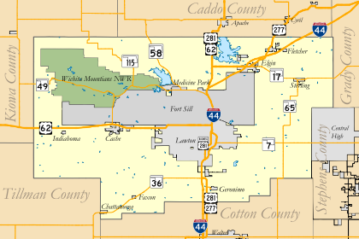
The operational structure flows from the individual ARES ARO to the Emergency Coordinator (EC).

Organization Chart

NOTE: The structure repeats identically for each team leader, but is not represented graphically to save space and maintain readability.

Operational Roles and Responsibilities

Amateur Radio Operator
- Individuals licensed by the FCC to operate on Part 97 bands.
- Assigned to a team and reports to a Team Leader.
- Responsible for their training as operators, and personal equipment readiness.
- Accurately and efficiently sends, receives, and routes voice and data traffic.

Team Leader
- Reports to their assigned AEC or the EC.
- Responsible for the organization and readiness of the ARES AROs assigned to their team.
- Responsible for the knowledge of the equipment at their Served Agency and any ARES equipment used in the field.
- Also performs ARES ARO duties as needed.

Assistant Emergency Coordinator
- Assumes role of EC if EC is unable to serve.
- Coordinates the organization and readiness of the teams assigned to them.
- Coordinates with Administrative Staff to facilitate the needs of AROs and Team Leaders.
- Coordinates reassignment of personnel as necessary during non-operational periods.
- Facilitates reassignment of volunteer personnel during emergencies as necessary.
- Assists EC, Team Leaders, and administrative staff as needed.

Emergency Coordinator
- Reports to Multnomah County Emergency Manager.
- Performs roles and responsibilities as defined by Oklahoma Section Manager.
- Coordinates and oversees all CCARES activities.

Activation Procedures
Comanche County ARES presents itself as a cadre of trained and proficient radio operators that are willing to assist the agencies we serve in the event of any incident that might require communications resources that are beyond those normally required. The potential uses for the ARES radio operator are varied, and as such, it is impractical to attempt to cover all potential activation procedures down to the minute detail. This procedure, therefore, serves as an outline and guide for activation and should be employed when practical. Operation of the Amateur Radio Emergency Services (ARES) operating component of this volunteer cadre will be in line with Part 97 Rules & Regulations of the FCC code. Any applicable components of this procedure will be adhered to, as well as any additional limitations from those rules and regulations.
The foremost rule for ARES AROs is that we do not self-deploy. When an amateur radio operator becomes aware of an incident that may require additional communications resources for which they may be suited, they are to establish communications from their location with the ARES unit via the Resource Net. Members should double-check and make ready their communications equipment, deployment materials, and 72-hour go-kits at this time.
The need for ARES operators should be relayed through the Comanche County Emergency Manager. The individual directed to activate ARES (the EC or designee) will relay that information to the Resource Net and deploy operators as requested by the Incident Commander (IC).
The need for ARES amateur radio operators will be communicated to the membership by:
- Self Awareness - If there is an obvious weather or disaster emergency that could affect communications infrastructure, then the ARES ARO is to check into or establish the Resource Net as appropriate. This should occur on the assigned repeater if available or on an appropriate simplex channel if no repeaters are available.
- Direct Contact – If ARES is needed by the county or other requesting party, the EC or designee will contact the team members by their preferred method of direct contact. This could be phone, text, or email, if available.
- Oklahoma HF Net (7260KHz/3900KHz) – The net will be used as the communication method of last resort for activation of Comanche County ARES.
Activation of the Resource Net
In the event of an emergency, the first order of action is to determine the communication resources available in Comanche County. The Net Control operator will activate the Net Control Station (NCS) using the designated repeaters listed in the Incident Communication Plan (ICS-205). The first amateur radio operator available should establish the CCARES Resource Net on CC-2 (147.360 MHz). If the repeater is disabled, establish the Resource Net on CC-5 (147.360 Simplex).
Amateur radio operators should check into the Resource Net with their FCC callsign. When recognized by Net Control, they should be prepared to give Net Control the following information:
- Name
- Location by nearest major cross streets
- Available equipment, including communications and transportation resources
- ARES Team, CERT team, or other primary response obligation if applicable
- Ability to deploy and for how long you can serve
- Any other information deemed necessary or requested by EC
The Net Control operator on the Resource Net will maintain the list of available operators (Check-in List ICS-214) with their reported information and deliver it to the EC or the appropriate designee when requested, digitally if possible.
Deployment assignments will be made by the EC or their designee on the Resource Net. When AROs have completed their assignments and been released, they will check back into the Resource Net to either secure or be reassigned.
CERT members will also initially report to the ARES Resource Net. Comanche County Emergency Management will assign CERT members to their operational frequencies from the ARES Resource Net. Once CERT members have been transferred to the CERT frequencies, Emergency Management will assume responsibility for them. They do not need to check back to the ARES Resource Net after their assignment.

Deployment Procedures
ARES AROs assigned to a team can expect to be deployed to either a served agency or a field station. Unassigned AROs will be deployed as requested by the EC or Comanche County Emergency Management. We will make every effort to keep AROs as close to their home geographic location as possible. However, dynamic situational requirements dictate that we are unable to guarantee an ARO will be sent to a particular location. The team leaders and AECs will schedule AROs for initial and relief shifts in a prolonged deployment.
Initial Actions during an Emergency
- The Net Control station and/or ARES officials on the designated emergency net will provide additional instructions, including information on frequencies used for other resource and tactical nets. Normally, a Resource Net will enroll volunteers and provide information on how you can assist.
- Be prepared to operate. Check all equipment and connections.
- When deployed, check in with your assigned contact. Deploy to assignment with Go-kit.
- Obtain a tactical call sign for your location/assignment.
- Use log form (ICS-309) to record messages handled.
- Use a formal message form (ICS-213) when a precise record is required.
- Use a tactical call sign for your location, and observe FCC’s 10-minute ID rule.
- Monitor your assigned frequency at all times. Notify the Net Control station if you have to leave.
Standard Communication Protocols for Nets and Traffic Handling
In general, amateur radio operators in Comanche County are expected to adhere to the following:
- Follow the net-scripts given below for operating in the event of an emergency.
- If a repeater that we normally use for communications is damaged and inoperable, we may conduct the communications in simplex mode on the output frequency of that repeater. For example, MC-2 would be MC-12 (147.280 simplexes) in the event of repeater failure. Alternatively, we may move to a different repeater.
- All communications go through Net Control. Do not call a station directly without Net Control permission.
- When checking into a net for the first time, use your personal FCC callsign using ITU phonetics followed by your tactical callsign. Thereafter, use only your tactical callsign to initiate contact, then end the contact with your tactical and personal callsign.
- We initiate contact in the format: "(station you are calling), (your callsign/),” then wait to be acknowledged.
- Whenever possible, the net and traffic handling protocols of the NTS should be adhered to, including the use of pro-words.
- If you have messages to relay, call "Net Control, (your callsign), with traffic.” Net Control will ask you to list your traffic. State number of messages and the tactical call of the receiving station. Net Control will then ask the receiving station to call you to receive your traffic.
- If the net is busy, Net Control may ask you and the receiving station to go to a different frequency to pass the traffic. When finished both stations should return to the main net with tactical callsign and “recheck.”
Types of Emergency Nets
- If you have messages to relay, call "Net Control, (your callsign), with traffic.” Net Control will ask you to list your traffic. State number of messages and the tactical call of the receiving station. Net Control will then ask the receiving station to call you to receive your traffic.
- If the net is busy, Net Control may ask you and the receiving station to go to a different frequency to pass the traffic. When finished both stations should return to the main net with tactical callsign and “recheck.”
Types of Emergency Nets
Resource Net (CC-2, 147.360 MHz) - For all incidents, a Resource Net is used to track and delegate operators and equipment in support of operations on the Tactical Nets. As an incident requires more operators or equipment, the Resource net evolves as a check-in place for volunteers to register and receive assignments. All CCARES AROs check back with the Resource net at the end of their assignment or deployment.
Command Net (CC-1, 147.910 MHz) - This net allows the incident managers to communicate with each other to resolve inter- or intra-agency problems, particularly between cities or within larger jurisdictional areas. It is conceivable that this net could become cluttered with a high volume of traffic. It may also be necessary to create multiple Command Nets to promote efficiency.
Tactical Net – (CC-3, 442.750 MHz) - The Tactical Net is the front line net employed during an incident, usually used by a single government agency to coordinate with Amateur Radio operations within their jurisdiction. There may be several Tactical Nets in operation for a single incident depending on the volume of traffic and number of agencies involved. Communications include traffic handling and resource recruiting.
Incident Radio Communication Plan (ICS-205)
TBD
Digital Operations – Winlink
Comanche County ARES digital operations are primarily based on Winlink Express, using RMS packet messaging. For more information on Winlink and RMS messaging, and to download the software, go to www.winlink.org.
Standard equipment includes:
- VHF/UHF radio.
- Packet TNC or sound card modem.
- Computer with Winlink Express software installed.
RMS Addressing:
All agencies served by ARES RMS messaging are assigned a (callsign)@winlink.org address.
RMS Gateway:
Comanche County ARES uses the Comanche County RMS Gateway as a primary gateway, and it should be used for most RMS activity. For drills, events, and incidents that do not impact internet connectivity in the region, any RMS gateway can be used to successfully transmit messages to served agencies.
If all local gateways lose internet connectivity and go into a local delivery mode, ARES will use N7DOD-10 as a coordinating gateway.
- Primary Gateway N7DOD-10 442.750 Comanche County
- HF Pactor is available for Winlink at Comanche County ARES trailer.
Digital Operations – SSTV
Comanche County ARES uses SSTV to provide images from the field to the Emergency Management or any emergency operations center (EOC) able to receive them.
EOC and ECC equipment consist of a Windows computer with MMSSTV software and a SignaLink or other sound card-radio interface. Images may be transferred from the field using the CCARES digital go-kits, radio, and cell phone with a camera and SSTV software via acoustic coupling, or operators' equipment which will include radio, laptop computer with SSTV software, sound card-radio interface, and digital camera or cell phone camera.
All images should include a specific location (street address or GPS coordinates). Operators who have images to transmit should contact Net Control on the Command Net to be directed to the appropriate frequency for SSTV transmissions.

Deployment Checklist

Pre-Deployment
- ARES members will verify the recall roster monthly.
- ARES members will register and update radio equipment.
- ARES members will verify Go-Kit/Go-Bag quarterly.
- ARES members will attend monthly meetings at least quarterly.
- ARES members will attend weekly Radio Nets at least monthly.

Activation (Recall)
- Notification by a served agency for assistance.
- EC/AECs will activate ARES members and authorize deployment.
- AEC-Administration will start activation recall procedures.
- AEC-Operations will activate the Resource Net Control Station (NCS) using the designated frequencies listed in the Incident Communication Plan (ICS-205).
- The EC/AECs will announce the deployment briefing area for muster.
- The Incident Commander will use the Incident Command Briefing (ICS-201) to provide ARES members with basic information regarding the incident situation and resources allocated to the incident.

Deployment
- EC/AECs will activate the Command NCS using the designated repeaters listed on the Incident Communication Plan (ICS-205).
- The Resource NCS will record all arrivals and departures of ARES personnel in the Check-in List (ICS-211).
- The General Message (ICS-213) will be used by incident dispatchers to record incoming messages that cannot be orally transmitted to the intended recipient.
- The Activity Log (ICS-214) will be used by the Resource NCS and ARES members to record the notable activities at your assignment. The log will provide basic incident activity documentation and a reference for the after-action report.
- The Communication Log (ICS-309) will be used by Resource NCS as well as any operator assigned to a location.
- ARES members will remain on the Resource NCS at all times until properly released.

Post-Deployment
- ARES members will tear down stations and equipment once approved by the EC/AECs or Incident Commander.
- ARES members will turn in all served-agency-issued equipment and required documents.
- ARES members will notify Resource NCS that you are leaving the site and returning to Staging Area.
- The EC/AECs or Incident Commander will conduct after-action debriefing and welfare checks.

Recovery
- Request permission to depart location/position.
- Return all served-agency equipment, including documentation.
- Turn in ARES-issued equipment.
- Turn in completed ICS forms.
- Inventory all equipment and notify your Team Leader or EC/AECs of any broken or lost equipment.
- Restock your personal Go-Kit/Go-Bag for your next adventure.

Appendix A – Leadership Contact Information
Name | Call Sign | Email | Position
Scott Burrows | N7DOD | N7DOD@arrl.net | EC
Aaron |  |  | AEC – Operations
TBD | TBD | TBD | AEC – Training
Leslie Burrows | KJ7EZO | KJ7EZO@arrl.net | AEC – Administration
 |  |  | Net Manager
 |  |  | Training Manager
 |  |  | Webmaster
 |  |  | Alpha Team Leader
 |  |  | Bravo Team Leader
 |  |  | Charlie Team Leader
 |  |  | Echo Team Leader

Appendix B – Served Agency List

Appendix C – Sample Net Scripts
Resource Net Script
Note: The Net Control operator may adjust this script as necessary to suit the situational needs. Unspoken comments are in italics.
Net Control is to maintain the net roll (Check-in List ICS-211) until relieved. All logs need to be submitted to the AEC-Administration, NLT 72 hours after the conclusion. When transferring to a new Net Control operator it is preferred to send them the net roll in written format via Winlink if possible.

To initiate net and every 30 minutes or during a lull in net business:
Net Control: “This is (your name), (your call), Net Control for the Comanche County ARES and CERT team Resource Net. This is a directed net and stations are asked to remain on frequency until directed by Net Control. If you must leave, please advise. This net serves as the coordinating hub for amateur radio operators serving in Comanche County. The Comanche County ARES Emergency Coordinator or another designated representative will relay radio operator requests here as they are received. No station is to deploy until assigned on this net. All check-ins are welcome. Stations are asked to check in with their FCC callsign. Stations wishing to check in, or other stations with the business for the net, please come now.”
Acknowledge each station and request the following information:
Net Control: “The net acknowledges (callsign). What is your:
- Name.
- Location by nearest major cross streets.
- Available equipment, including communications and transportation resources.
- Comanche County ARES team, CERT team, or other primary response location.
- Ability to deploy, and for how long you can serve.
Acknowledge each station and request the following information:
Net Control: “The net acknowledges (callsign). What is your:
- Name.
- Location by nearest major cross streets.
- Available equipment, including communications and transportation resources.
- Comanche County ARES team, CERT team, or other primary response location.
- Ability to deploy, and for how long you can serve.
Every 10 Minutes:
Net Control: “This is (your name), (your call), Net Control for the Comanche County ARES and CERT team Resource Net.
To close the net when directed by EC:
Net Control: “This is (your name), (your call), Net Control for the Comanche County ARES and CERT team Resource Net. Thank you to all stations who participated in this emergency response effort and to all other stations who stood by to give us a clear operating frequency. (If the net was conducted on the repeater: “Comanche County ARES also thanks the Lawton Fort Sill Amateur Radio Club for the use of this repeater.) All stations may now secure. This net is closed at (local time) and the frequency is now returned to normal amateur radio use.”
Written station logs should be given to the EC and a copy to the Net Manager, as soon as practical.

Command Net and Tactical Net Script:
Note: The Net Control operator may adjust this script as necessary to suit the situational needs. Unspoken comments are in italics.
To open the net every thirty minutes or during a lull in net business:
Net Control: “This is (your name), (your call) as (club call if applicable), Net Control for the Comanche County (exercise or type of net) net. This is a directed net and stations are asked to remain on frequency until directed by Net Control. If you must leave, please advise. This net serves as the communications center for (exercise or incident net type). Stations are asked to check in with their tactical callsign. Stations are reminded to sign at the end of every communications string with their tactical callsign and personal FCC callsign. Stations with the business for the net may come now.”
Every 10 Minutes:
Net Control: “This is (your name), (your call or club call), Net Control for the Comanche County (exercise) (incident and type of net) net.
To close the net when directed:
Net Control: “This is (your name), (your call), Net Control for the Comanche County (type of net) net. Thank you to all stations who participated in this (emergency response effort) or (name of the event) or (exercise) and to all other stations who stood by to give us a clear operating frequency. {If the net was conducted on the repeater: Comanche County ARES also thanks (the repeater owner) for the use of this repeater.} All stations may now secure and report back to the Resource Net. This net is closed at (local time) and the frequency is now returned to normal amateur radio use.”

Appendix D – Standard Forms
- ICS 100 – Blank Paper
- ICS 211 – Check-in List
- ICS 213 – General Message
- ICS 214 – Activity Log
- ICS 309 – Communication Log

ICS 211 – Check-in List
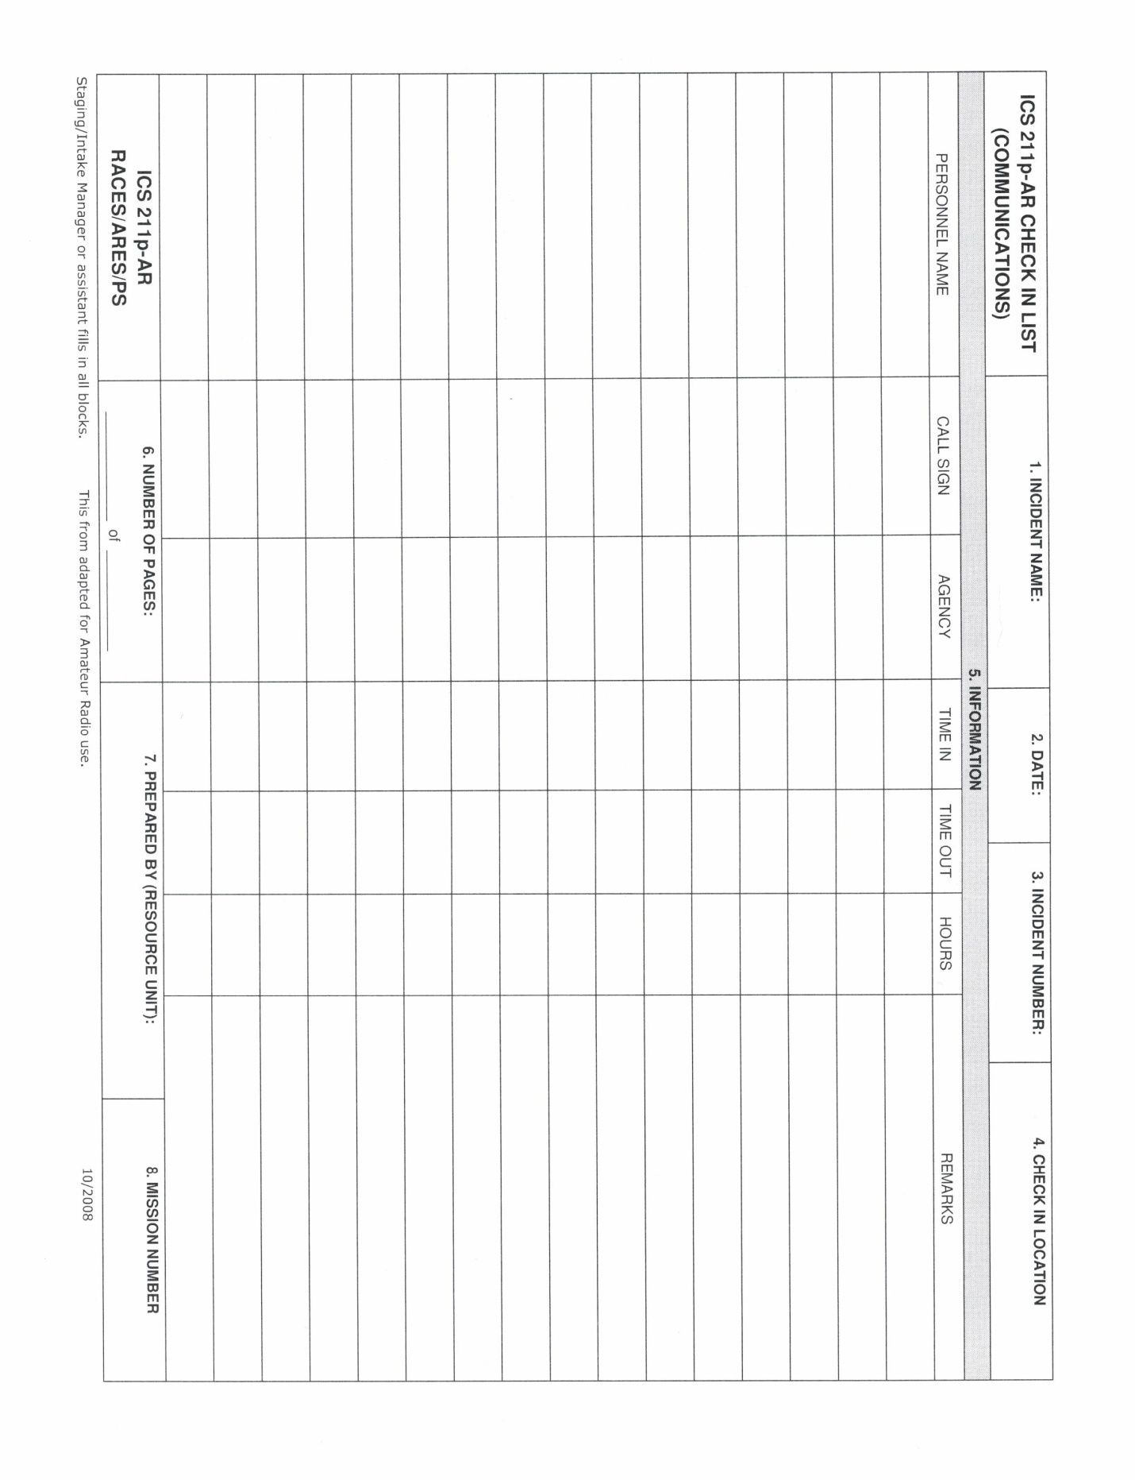
ICS 213 – General Message
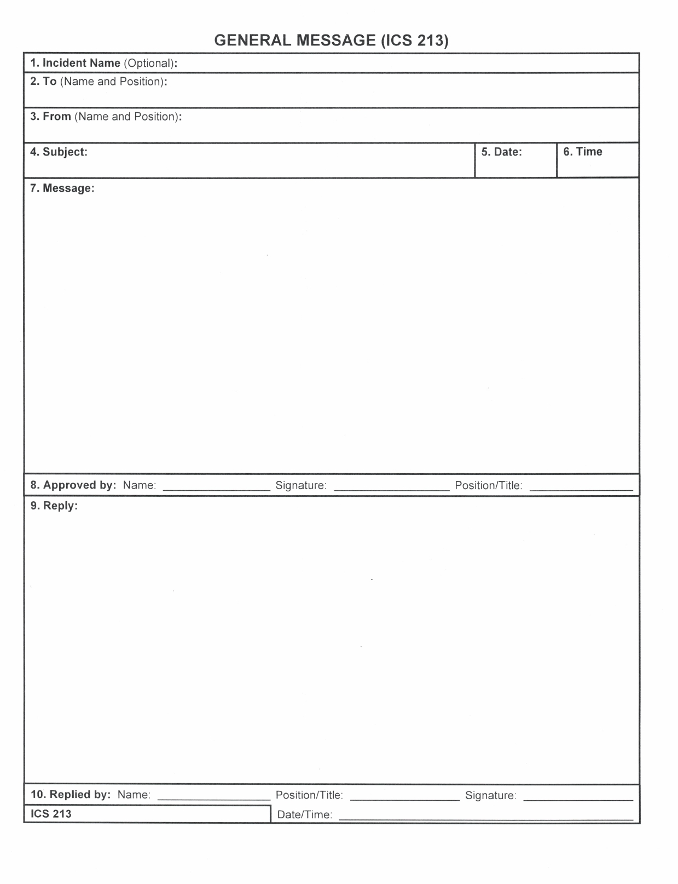
ICS 214 – Activity Log
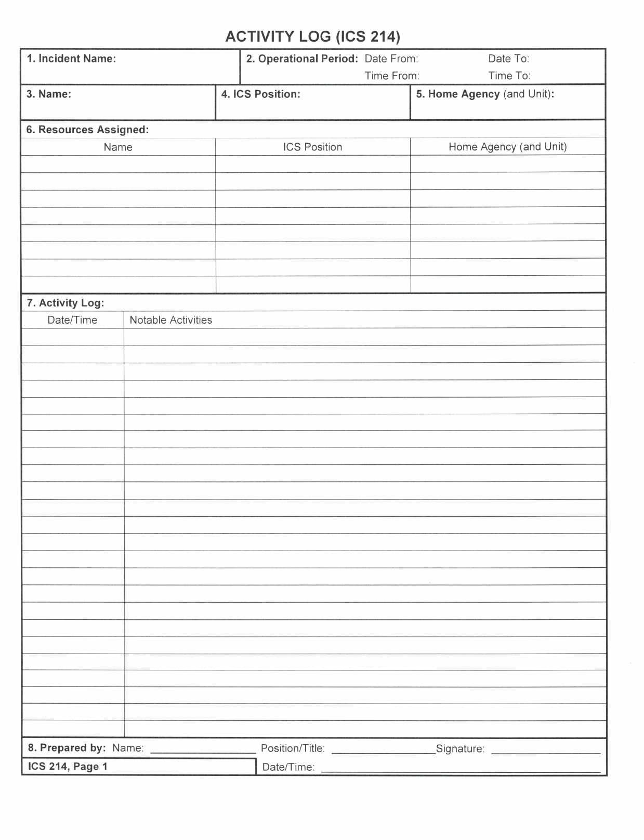
ICS 309 – Communication Log
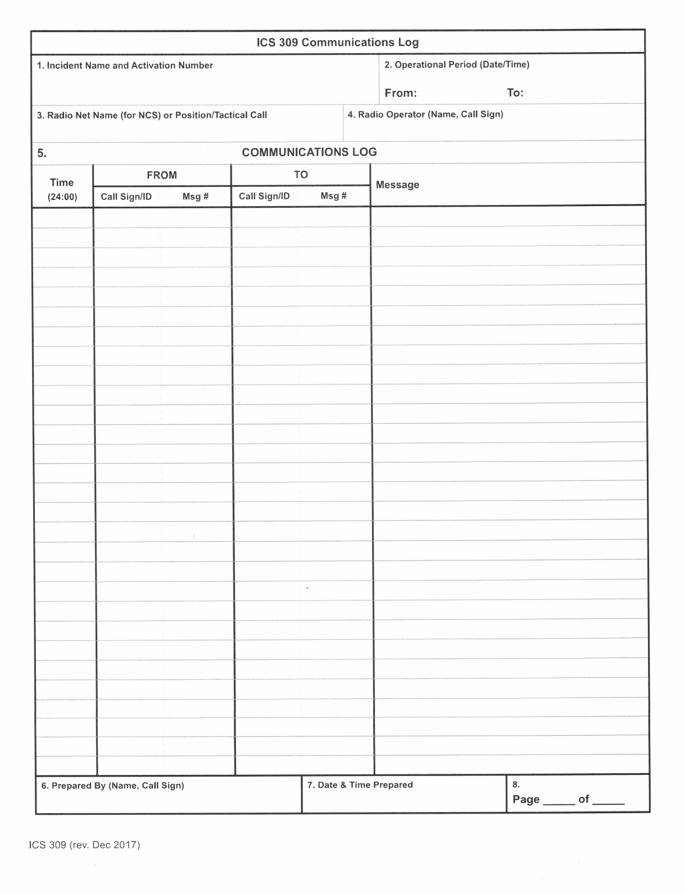

Appendix E – Administrative Roles and Responsibilities
Membership Manager
- Welcomes new members, sends an orientation packet, introduces Team Leader and new member trainer. Informs of the resources available.
- Maintains membership records and Google Drive roster with current contact information of all members.
- Collects ICS documents for each member and coordinates with Training Manager for ARRO certification.
- Distributes “records check” form to qualified members.
- Records membership participation at monthly meetings, events, drills, and SETS.
- Maintains Google Group email reflector.
- Assists members with any special needs.
Training Manager
- Sets forth the annual training schedule.
- Coordinates any training resources needed.
- Is available to team leaders and can assist with team-level training.
- Arranges ARRO certification workshops and coordinates other CCARES certifications with other leadership personnel
- Maintains training records on Google Drive.
Net Manager
- Earn NCFO Certificate
- Coordinate with Team Leaders to assure a Net Control for every Wednesday weekly net. Teams are assigned by the month to provide Net Controls.
- Send a reminder email to each Net Control. Include the current Net Control script.
- Receive Net Control reports and record check-ins on the Google Drive spreadsheet.
- Maintain Net Control script
- Attend Leadership meetings and help out where needed.
Webmaster/Social Media
- Maintains the https://ares-ccares.org website and keeps all information therein current.
- Responsible for Comanche County ARES presence on social media including Facebook and Twitter.
PIO
- Responsible for public outreach and recruitment and leads recruitment drive for new members.
- Coordinates ARES promotion and recruitment at local public service events and emergency preparedness fairs.
- Recruits members to represent ARES at recruitments and outreach functions

Approved and Adopted

Scott Burrows, N7DOD 00/00/2022
_________________________________________________ ________________
Approved, Comanche County Emergency Coordinator Date

Aaron Epley, KI5THW 00/00/2022
_________________________________________________ ________________
Assistant Emergency Coordinator Date

Leslie Burrows, KJ7EZO 00/00/2022
_________________________________________________ ________________
Assistant Emergency Coordinator Date

